

Dynamics 365 Manufacturing Accelerator Base Solutions

Installation Guide

**Published**: May 2020

**Accelerator Release Version**: May 2020

Table of Contents

Introduction 3

Prerequisite Files 3

Main Solutions 3

Additional Solutions 3

Installation Steps 4

Manually Import Main Solutions 4

Provision the Portal 4

Import Additional Solutions with Configuration Migration Tool 7

Update Website Binding 7

Portal Authentication Configuration 9

Prerequisites 10

Power BI Integration 14

Prerequisites 14

Model Driven App 14

Portal 15

Reference 16

Data Migration Utility (Configuration Migration) 16

# Introduction

The purpose of this document is to provide a guide on installing and configuring Dynamics 365 Manufacturing Accelerators solutions.

# Prerequisite Files

Make sure the CDS default solution (which comes preexisting in the environment) is present which included entities like Contact and Accounts.

# Main Solutions

For a list of all entities and attributes, find the Manufacturing Reference Guide amongst the included documentation. To import, follow steps in the “Manually deploy Main Solutions” section below. Solutions must be installed in the following order:

1. Dynamics 365 Manufacturing Accelerator
   1. Name: Dynamics365ManufacturingAccelerator
   2. Description: This solution contains the entities, forms, and views used across the accelerator.
   3. Dependencies:
      1. None
2. Dynamics 365 Manufacturing Accelerator Model Driven App
   1. Name: Dynamics365ManufacturingAcceleratorModelDrivenApp
   2. Description: This app contains, Dynamics Customizations solution, Dashboard and Model Driven App.
   3. Dependencies:
      1. Dynamics365ManufacturingAccelerator

# Additional Solutions

This solution contain Sample Data for the Manufacturing Solution and Model Driven Admin App Solution. To import, follow steps in the “Import Additional Solutions with Configuration Migration Tool” section below.

1. Dynamics 365 Manufacturing Accelerator Sample Data
   1. Name: Dynamics365ManufacturingAcceleratorSampleData.zip
   2. Description: The data package contains data related to Question entities.
   3. Dependencies:
      1. Make sure all the solutions mentioned above under “**Main Solutions**” are imported.

# Installation Steps

## Manually Import Main Solutions

To manually import a main solution:

1. Navigate to <https://make.powerapps.com/home> > Select your Environment > Click Solutions in left-hand Navigation.
2. Click Import button in ribbon.
3. Click Choose File button and select managed solution zip file under main solution heading one by one.
4. Click Open button.
5. Click Next through all steps and then Import.

## Import Additional Solutions with Configuration Migration Tool

To Import an additional solution using the Configuration Migration Tool:

1. Open “Configuration Migration Tool” folder (**Note:** Make sure folder is on Desktop so directory name is short). In order to download this tool, see heading “**Data Migration Utility (Configuration Migration)**” below in the document.
2. Open the new “Tools” folder, then “ConfigurationMigration”, and run “DataMigrationUtility”.
3. To Import:
   1. Select “Import Data”.
   2. Connect to the org to import the data to.
   3. Select the appropriate data zip file along with
   4. Perform the import.

## Power BI Integration

The Dynamics 365 Manufacturing Accelerator is shipped with two Power BI reports namely **Admin** and **Manager Dashboards**. The user can customize these reports as per there needs.

### Prerequisites

In order for Power BI reports to show in Model driven app, follow this [link](https://docs.microsoft.com/en-us/powerapps/maker/portals/admin/set-up-power-bi-integration#enable-power-bi-visualization).

### Model Driven App

In order to view Power BI Dashboards, open the Model driven app. Go to **Reporting** and click **Power BI dashboard** under **New** button. And select **workspace** and **dashboard** to add here.

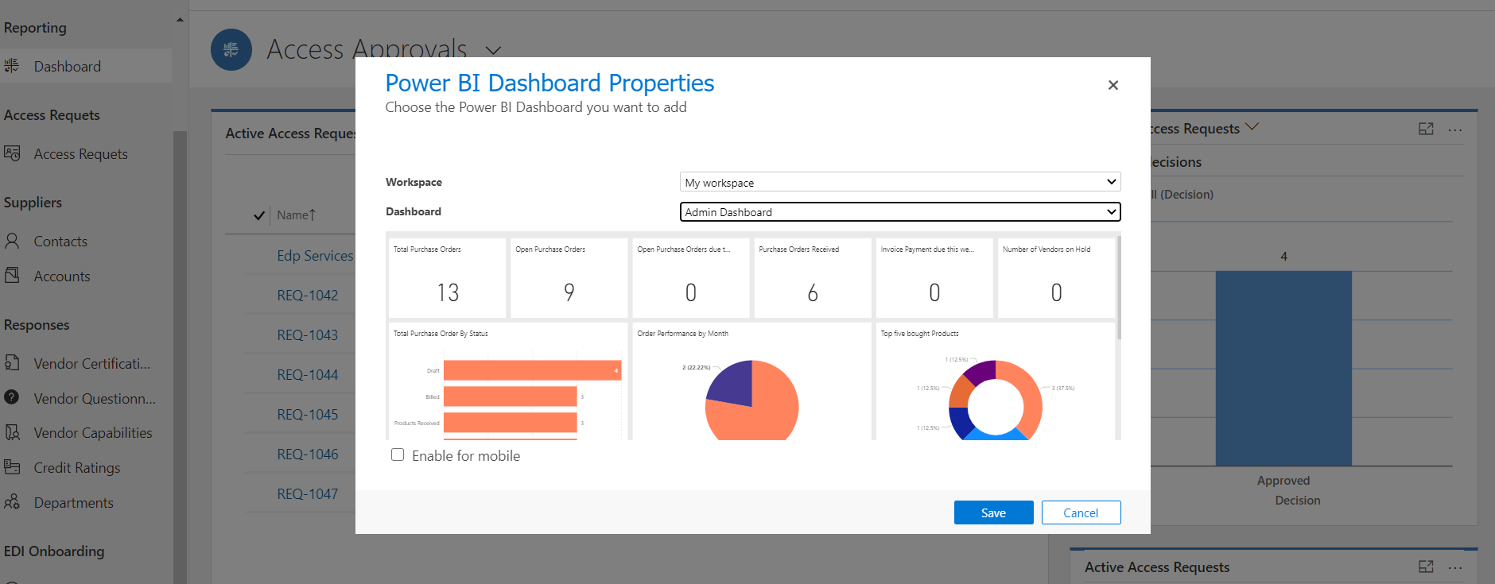

# Reference

## Data Migration Utility (Configuration Migration)

The document explains how to import data to Microsoft Dynamics 365 CRM using the “Data Migration Utility”, which should be downloaded before starting the import process.

To download the tool please refer to the following link: <https://www.nuget.org/packages/Microsoft.CrmSdk.XrmTooling.ConfigurationMigration.Wpf>

To run the tool, once downloaded, extract the files and double click on the application named “DataMigrationUtility.exe”.

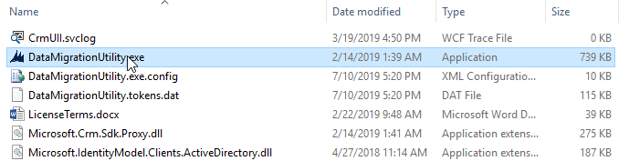

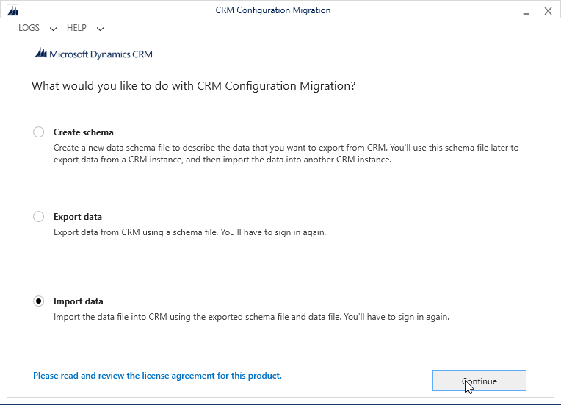

Provide the user and password for the environment that you want to import the data and press “Login”. Note that you may need to change the “Deployment Type” and “Online Region” based on the environment that you are using.

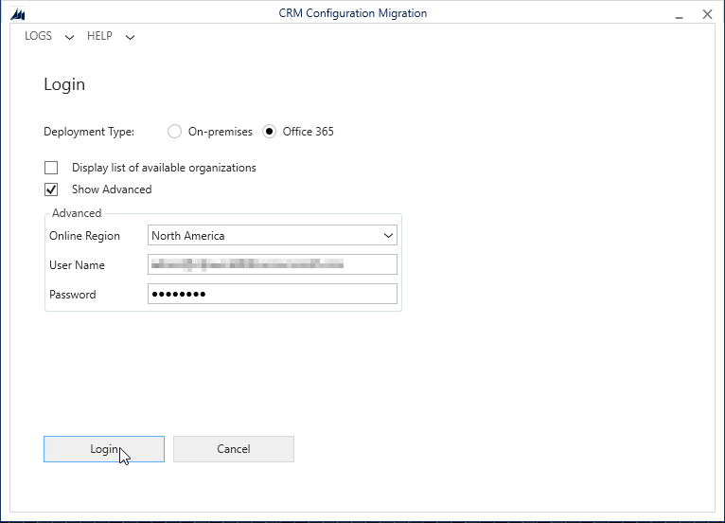

Once authenticated, click on the search button to search for the sample data package.

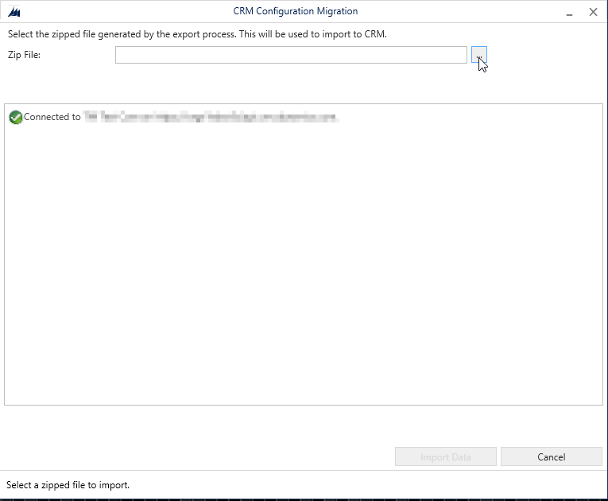

A search window will appear. Locate and select the previously downloaded data package and press “Import Data” to begin the import process.

